- The Monetary Policy Committee narrowly voted to cut Bank Rate by 25bps to 5% at its August meeting. The MPC's core message was that rates will be cut further, but at a measured pace.
- Those voting for a cut have become more confident in their understanding of the inflation generation process and argued such a restrictive policy stance was no longer necessary. But the decision was finely balanced for some of this group, and they emphasised that the risks to inflation are skewed to the upside.
- Consequently, we think rate cuts at successive meetings are unlikely and expect Bank Rate to stay at 5% in September. The MPC will also likely maintain the current £100bn per year pace of quantitative tightening at that meeting. We expect the next 25bps rate cut to come in November and continue to forecast 100bps worth of cuts in 2025.
The Bank of England's Monetary Policy Committee voted 5-4 to cut Bank Rate by 25bps to 5% at today's meeting. In our recent preview, we had argued that the conditions were in place for the MPC to cut, but that market reaction to the recent overshoot for services inflation might cause them to pause. In the event, despite an absence of news that would justify such a move, market pricing had shifted to around 60/40 in favour of a rate cut in recent days, giving cover to a cut for those who were wavering.
The minutes of the August meeting made clear that the MPC remains deeply divided. Those voting to hold argued that upside surprises for services inflation and GDP growth suggested that underlying inflation pressures remain strong and, as a result, the Committee's modal forecast for inflation is too low.
Those voting to cut continued to preach the more forward-looking approach that was introduced in June's minutes, arguing they understand the inflation-generation process better now than they had previously, thus reducing the importance of backward-looking indicators. They supported their narrative with a new forecast that showed CPI inflation at 1.7% in two years' time and 1.5% three years out (Chart 1). This projection was based on market interest rate expectations that showed around 100bps of further rate cuts by the end of next year.
Chart 1: Inflation being expected to drop well below target was a key argument for cutting rates
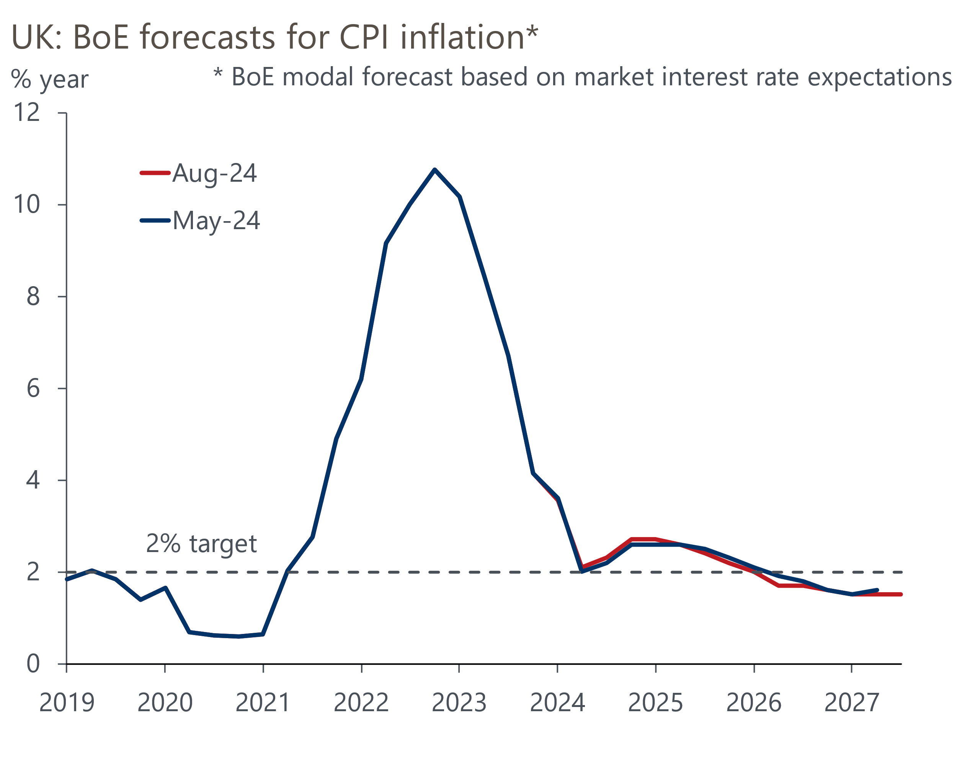
Source: Bank of England Monetary Policy Report

But while the model forecast suggests this is likely to be the start of a series of rate cuts, the MPC was at pains to emphasise that the pace of loosening will be gradual. In his opening remarks, Governor Andrew Bailey said: "We need to put the period of high inflation firmly behind us and we need to be careful not to cut rates too much or too quickly". The minutes also suggested that for some of those who voted to cut, the decision was finely balanced, mimicking the language used in June when those members had voted to hold. We think these members – likely to be three of the five internals, Andrew Bailey, Sarah Breedon, and Clare Lombardelli – are unlikely to be thinking in terms of cutting at successive meetings, and the forecast process is likely to be core to their thinking.
The MPC emphasised the uncertainty around the outlook for inflation and, therefore policy, by publishing a mean forecast that showed inflation closer to the 2% target over the medium-term (Chart 2). The upside skew to the risk profile reflects the uncertainty around domestic inflationary pressures.
Chart 2: The MPC views the risks to inflation as being skewed to the upside
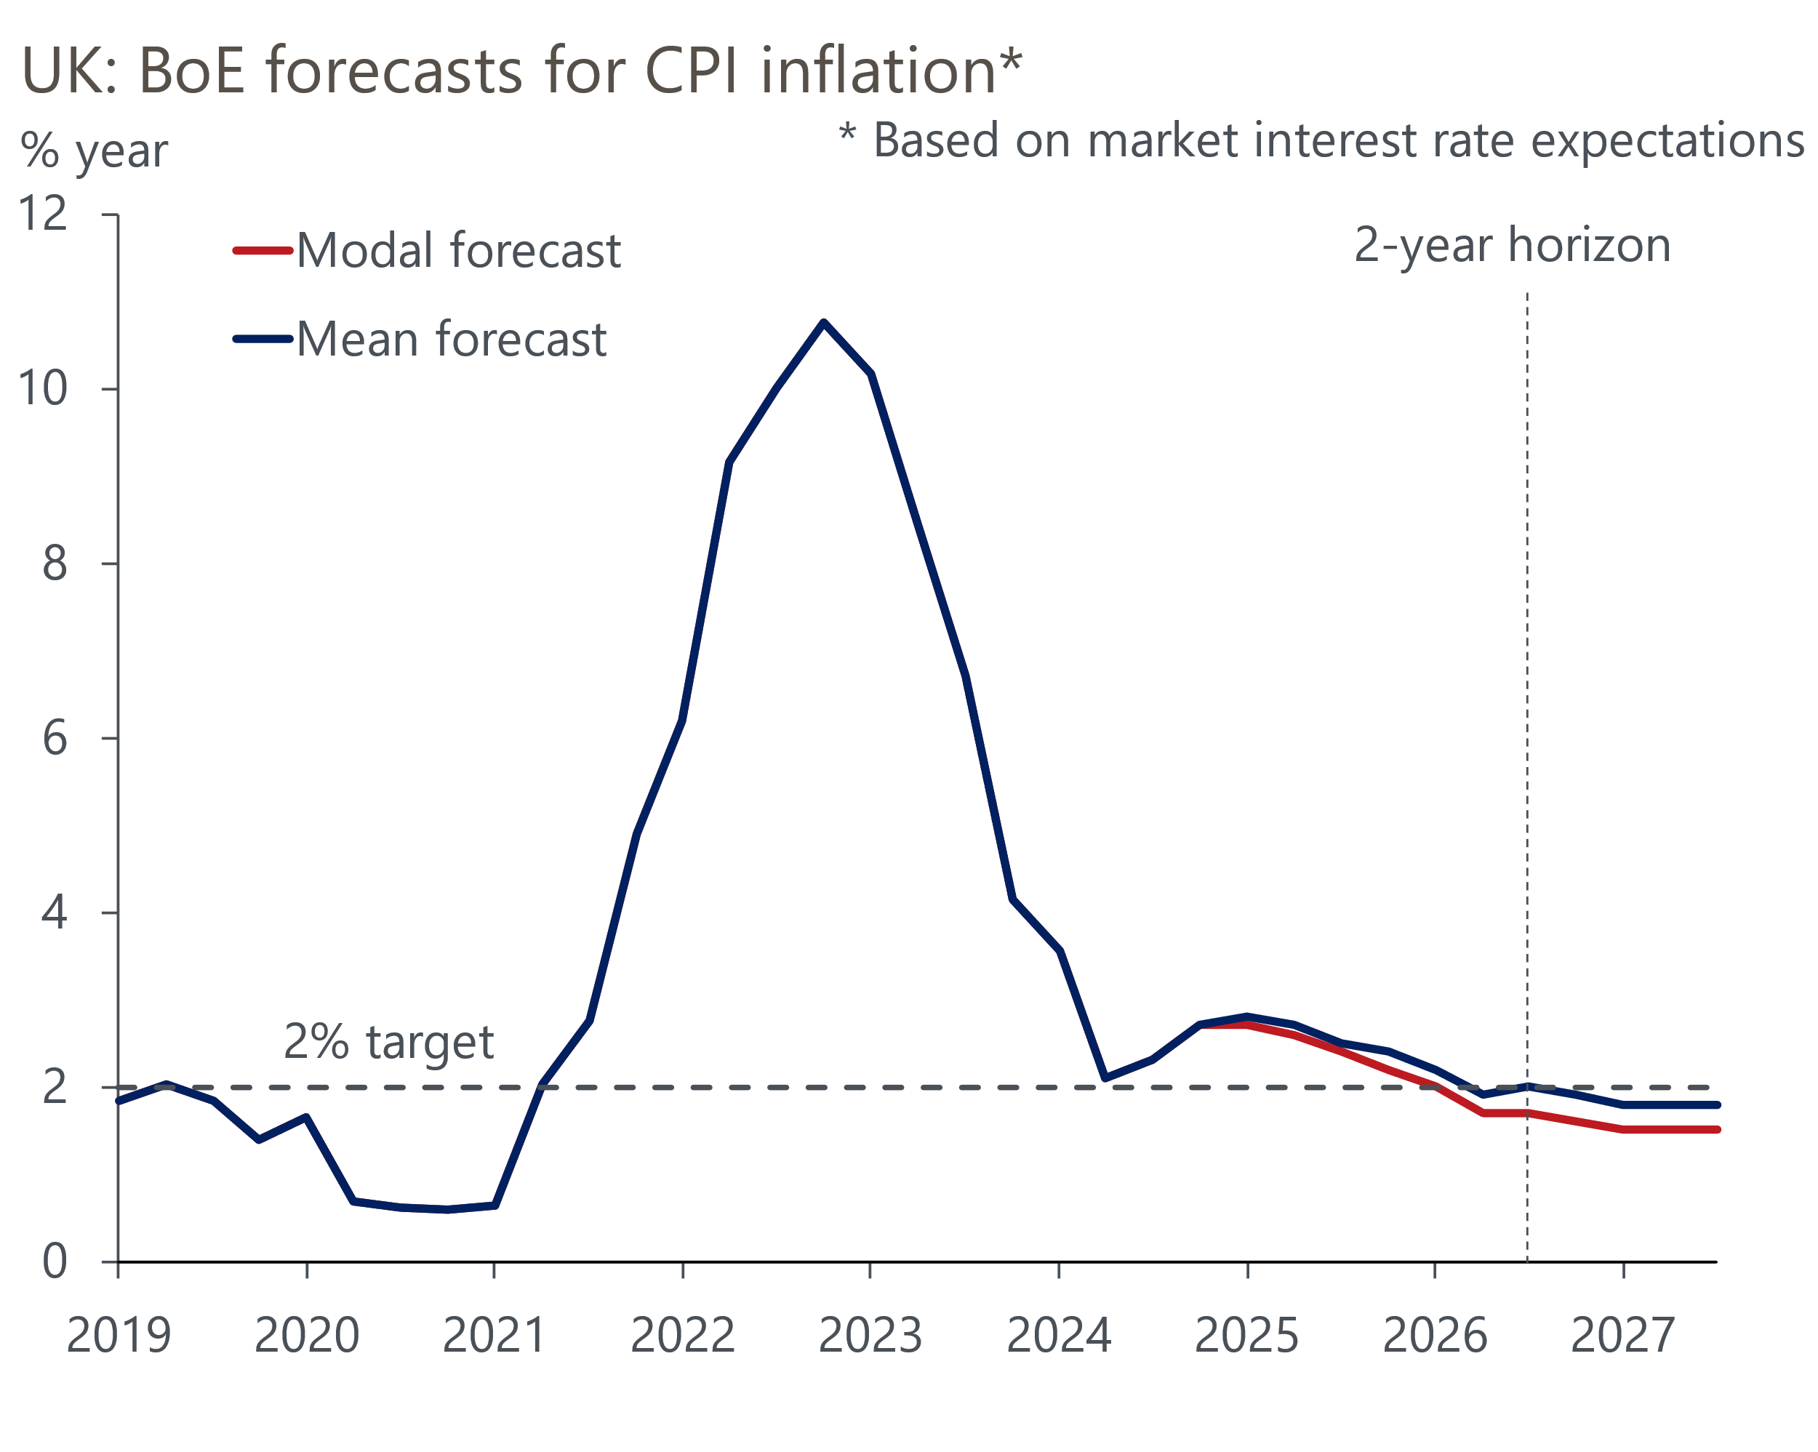
Source: Bank of England Monetary Policy Report
Those voting to cut took the view that much of the recent upside surprise in services inflation was due to factors that are less relevant to future trends. The Monetary Policy Report included a new measure – services inflation excluding indexed and volatile components, rents, and foreign holidays – to back this view. The doves expect services inflation to drift downwards, backed by forward-looking survey data such as the BoE's Decision Maker Panel. They also expect core goods price inflation will stay close to zero. But they acknowledged the concerns of the hawks, that "inflationary persistence had not yet conclusively dissipated" and that "there remained some upside risks to the outlook."
Doubt around the composition of the MPC will add to the sense of uncertainty around future decisions. This was Jonathan Haskel's final meeting, and his replacement is yet to be announced. This means there's a good chance that September's meeting will take place with only eight members voting, five of whom voted to cut this time. However, the desire to move slowly among some of those who voted to cut means that we expect the committee to keep Bank Rate at 5% in September.
At the September meeting, the MPC will also vote on the pace of quantitative tightening over the coming year. Today's MPR included a box that concluded the impact of QT on gilt yields and the real economy had been small. The MPC also made clear it sees no conflict between cutting rates and continuing with QT. So we stick with our view that QT will continue at the current pace of £100bn for the year ahead.
November's MPC meeting will be held shortly after the October Budget, but we doubt it will derail another rate cut at that meeting. Indeed, the likelihood is that the Budget will include sizeable tax hikes and credible multi-year fiscal tightening, which will help reinforce the case for lower rates. So we continue to expect another 25bps cut in November, leaving Bank Rate at 4.75% at year end. We forecast 100bps of rate cuts in 2025, consistent with the message from the MPC's modal forecast that the slower pace of loosening implied by current market pricing would result in inflation undershooting the target over the medium-term.

Key passages from the MPC minutes
“Five members preferred a 0.25 percentage point reduction in Bank Rate at this meeting. It was appropriate to reduce slightly the degree of policy restrictiveness. The impact from past external shocks had abated and there had been some progress in moderating risks of persistence in inflation. There had been a normalisation in inflation expectations, and forward-looking indicators such as the Decision Maker Panel survey pointed to waning wage and price pressures. The recent strength in services inflation had in part continued to reflect more volatile components of this series. Although GDP had been stronger than expected, the restrictive stance of monetary policy continued to weigh on activity in the real economy, leading to a looser labour market and bearing down on inflationary pressures. For some of these members, the decision was finely balanced. Inflationary persistence had not yet conclusively dissipated, and there remained some upside risks to the outlook."
Our interpretation: At the June meeting, two of this group voted for a cut and the other three gave a strong hint they were likely to vote for a cut in August, provided the forecast process was supportive. The clear message from this group is that they feel they have a better understanding of the inflation generation process and so can adopt a more forward-looking approach and reduce their reliance on backward-looking indicators. That some of this group saw August's decision as finely balanced emphasises that they are unlikely to vote for cuts at every meeting. Given the importance of the forecast process, we think they will vote to cut at meetings that accompany an MPR, but hold in other months.
"Four members preferred to maintain Bank Rate at 5.25% at this meeting. The upside news to services inflation and GDP outturns relative to the May Report, along with continued elevated wage growth, suggested that second-round effects were having a greater impact on wage and price-setting behaviour in the economy beyond what was embodied in the modal forecast. External factors, such as international food and energy prices, had played the major role in reducing headline inflation to date. By contrast, underlying domestic inflationary pressures appeared more entrenched. These members thought that there was a greater risk of more enduring structural shifts, such as a rise in the medium-term equilibrium rate of employment, a fall in potential growth and a rise in the long-run neutral interest rate, contributing to domestic inflationary persistence. They preferred to maintain the current level of Bank Rate until there was stronger evidence that these upside pressures would not materialise."
Our interpretation: It was no surprise that these four voted to hold. In contrast to those voting to cut, this group still puts greater store on backward-looking indicators of inflation persistence. They are unlikely to change their minds until this data has decisively softened. This group is also likely to drop to three in September given this was Jonathan Haskel's final meeting. Given his replacement has not yet been announced, it looks likely that there will only be eight members voting at September's meeting.
"Monetary policy would need to continue to remain restrictive for sufficiently long until the risks to inflation returning sustainably to the 2% target in the medium term had dissipated further. The Committee continued to monitor closely the risks of inflation persistence and would decide the appropriate degree of monetary policy restrictiveness at each meeting."
Our interpretation: This was a similar formulation to previous months. It emphasises that policy is still restrictive, so there is space for rate cuts, but that the pace of rate cuts will be gradual.

